Lewis-Ward, Dawn 8681
Family intervention counselling service |
Transform Evaluation
FICS Evaluation of the HIGH-RISK programme within Warwickshire’s Domestic abuse perpetrator Programme (DAPP) framework
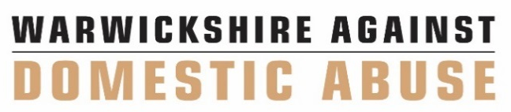
Executive summary
This report is a preliminary evaluation of the high-risk programme, Transform, which is delivered and managed by the Family Intervention Counselling Service (FICS). The programme is funded by the Home Office and Warwickshire’s Police and Crime Commissioner. The fundamental aim of the programme is to reduce future risk of high-risk intimate partner violence by addressing the individual emotional and psychological risk factors associated with each client (where possible) and/or to refer to other agencies for support. Transform consists of both group and individual sessions over a 9-month period. In total there are 23 individual sessions, which are 90 minutes long and 16 group sessions which are 2 hours long. The programme explores the following 7 modules:
- Barriers to change
- Optimism and resilience
- Emotional acceptance
- Reactivity and regulation
- How I got here
- Information processing and aggression,
- Consequences, interpersonal skills, and relapse prevention.
This evaluation will gather insight into the efficacy of the programme, where any improvements can be made and how the clients found being on the programme.
The programme considered 13 clients as suitable to participate in this programme. However, 5 clients withdrew before completion, 4 have completed the programme and a total of 4 are still in progress.
Of the 9 clients who progressed to starting the programme, 3 completed the programme as planned, utilising both individual and group sessions. The other 6 clients completed an adapted programme due to individual factors linked to stabilisation and emotion dysregulation. These 6 clients completed all sessions on an individual basis.
A focus group was held with 3 alleged perpetrators (AP) who had just completed the Transform programme as planned, attending the combination of individual and group sessions.
The three APs who completed the focus group were white males aged 28, 38 and 40. One AP reported being diagnosed with ADHD as a child however this did not affect him attending the group aspect of Transform. These men were referred into the service from March 2022 to September 2022.
When completing the analysis on the focus groups it showed the following themes:
- Positive feedback
- Negative feedback
- Impact of the programme
- Learnt skills.
Descriptive statistics were also carried out on all 13 referrals received for the Transform clients. This explored the reduction of incidents and severity of perpetration, increased personal wellbeing and confidence and increased understanding of abusive behaviour on self and others.
Risk assessments such as the B-Safer and SOAG are also completed before and after therapy by all clients. The analysis of the B-Safers and SOAGs of the 4 clients who have completed the programme showed that there has been a decrease in levels of risk.
Self-administered questionnaires were sent to each AP at the end of therapy. The questionnaire sought to gather a narrative understanding of the client’s experience of completing the programme. This feedback showed all four APs would recommend the service and gave positive feedback for both staff and the for the programme.
Staff also complete end of therapy questionnaires which measure engagement, personal interaction, prosocial steps, increased understanding, and perspective taking. The results from these showed all four participants had improved in all areas.
Future considerations centred on the logistics of programme delivery including the timing of sessions and access to additional materials. However, this is discussed further within the report.

