Lewis-Ward, Dawn 8681
Family intervention counselling service |
Warwickshire DAPP Evaluation
FICS Evaulation of the Warwickshire Domestic abuse perpetrator Programme (dapp) April 2022 – March 2023
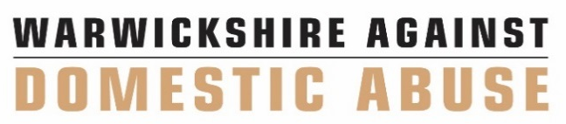
Executive summary
This is a second annual review of the Domestic Abuse Perpetrator Programmes (DAPP) service provided by the Family Intervention Counselling Service (FICS). This report will look at four programmes within DAPP.
- Engage – low risk.
- Change – medium risk.
- Transform – high risk.
- Safer families – 14 – 17-year-old programme.
The framework is funded by the Home Office and Warwickshire’s Police and Crime Commissioner. The fundamental aim of the framework is to reduce future risk of intimate partner violence by addressing the individual emotional and psychological risk factors associated with each client (where possible) and/or to refer to other agencies for support.
All programmes consist of both group and individual sessions. The individual sessions are bespoke, according to need but could include, amongst other aspects, understanding childhood experiences, managing difficult relationships and safety planning. Clients are assessed for suitability for the group aspect of the programme. This decision is based on risk and if a client is not able to engage with the group dynamics, work is completed on an individual basis.
The purpose of this evaluation is to take a 360 view of the project, gathering insight from service users, facilitators and the wider agencies who are part of overseeing the framework.
A total of 488 referrals were received from 1st April until the end of March 2023. 420 of these referrals are from within the domestic abuse police force. This is a process which is still being set up and 363 of these referrals are at a pre-referral stage so will not be included within this evaluation. However, the remaining 57 police referrals will be included as they were explored in some format. At the point of writing this evaluation, there were no clients engaged with the lowest risk intervention as a referral pathway is yet to be established.
Overall, the five outcomes which were measured were for the perpetrators:
- Sustained reduction, frequency and severity of abuse.
- Reduction in risk posed by the perpetrator.
- Improved safety/protection for connected victims and their children.
- Increased personal wellbeing and confidence.
- Increased understanding of abusive behaviours on self and others.

Overall, it is felt that the DAPP programme has been effective in reducing abusive behaviours and therefore reducing further victimisation. At the end point of this report, April 2023, there was still 21 clients within services. Therefore, they will be reported in the next annual evaluation.
The Integrated Therapeutic Support Service received 497 referrals, 428 of these referrals were from Warwickshire police. 437 were female and 60 were male from 1st April 2022 till the end of March 2023. A large majority were aged 30 – 39. 51 clients were White, 7 other, 5 Asian/Asian British, 3 mixed race, 0 Black and 430 did not state their nationally. Regarding sexuality, 46 partner support clients disclosed being heterosexual, 1 client disclosed being homosexual, and 450 clients did not state their sexuality. 52 had no disabilities, 22 did disclose a disability. The remaining 423 did not disclose whether they had a disability or not.
Four outcomes were measured within the Integrated Therapeutic Support Service, and these were:
- Sustained reduction, frequency and severity of abuse.
- Reduction in risk posed by the perpetrator.
- Improved safety / protection for connected victims and their children.
- Increased wellbeing and confidence.
Outcome measures are smaller for partner support due to these clients being in therapy significantly longer than their associated DAPP client. However, the results showed a significant reduction in risk and improved safety and wellbeing at the end of therapy.

