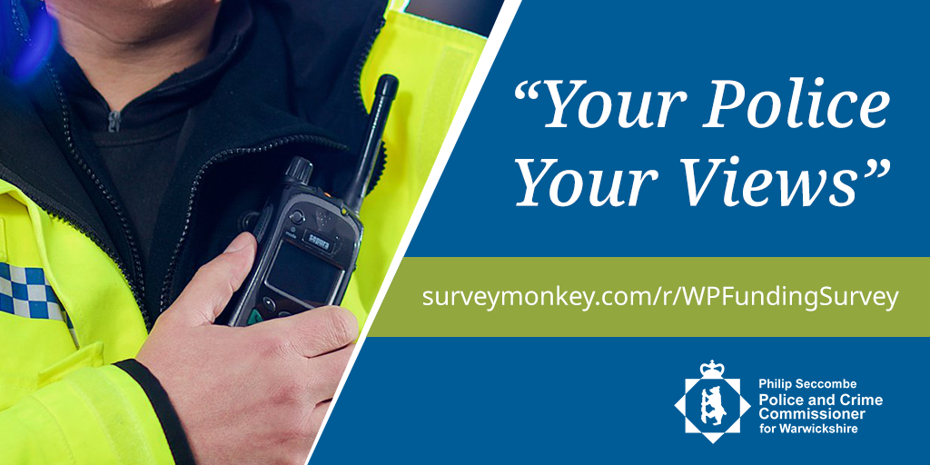
Your Police, Your Views
Warwickshire Police and Crime Commissioner Philip Seccombe wants to hear from the public about the future of policing in the county, as he launches a major new consultation ahead of deciding how funding should be prioritised in the year ahead.
The ‘Your Police, Your Views’ survey aims to get opinions from all parts of Warwickshire on how local people feel money should be spent on policing and community safety, including what types of initiatives should be financed through grants and commissioned services.
The questions also give the opportunity for people living and working in the county to provide further feedback on policing and community safety, to help understand the Commissioner understand what they feel works well and also what needs improvement.
The results will help inform the budget setting process for the 2021/22 financial year.
The survey is open now and will run until early January 2021 at: https://www.surveymonkey.co.uk/r/WPFundingSurvey

